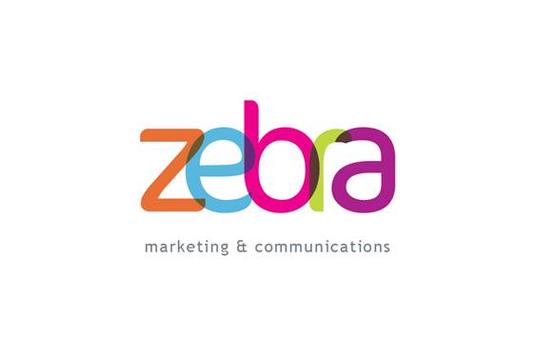

press release

Ref: PRS004.ZMC
Sent: 28 March 2011

Over £2,000 raised for children’s charity
A charity auction held in Chester last week (24 March) has raised over £2000 for children’s charity, Empowering Youth Foundation (EYF).

The event, hosted by local PR and marketing company, Zebra, took place at The Rectory Bar and the auction was run by Wright Manley auctioneer, Peter Lewis.

Clara Hughes, Director of Zebra, commented: “We are absolutely delighted with how the evening went and that we managed to raise so much money for EYF. We received so much support on the run up to the event and on the evening itself – and everyone appeared to have a really good time. I would like to say a big ‘thank you’ to our key sponsors, local law firm Walker Smith Way, our Auctioneer, Peter Lewis and everyone who donated their time and services to make the event a success. But of course, a huge ‘thank you’ has to go to our guests on the evening that really got into the spirit of the bidding and supported the charity with such enthusiasm.”

Dawn Roberts, Executive Director at EYF added: “We will soon be launching our Life Skills programme for youth in the Wrexham and Chester area and Zebra’s event was a great way to introduce our core values and mission to the local business community. Gaining support from the local businesses for fundraising and donations is a vital to sustainability of the programme. Zebra did a masterful job of helping get our message out to a wider audience than we could have imagined.’

Empowering Youth Foundation (EYF) is a registered charity which teaches life skills to youth facing cultural, social or economic challenges, through the medium of sport, in particular golf. EYF was established in 2008 and has successfully reached more than 3,000 youth since its start. As demand for the life skills programmes has increased, EYF has begun to introduce programmes into more locations.

For more information on the charity and how you can get involved, please contact Empowering Youth Foundation on 01978 345222 or email info@empoweringyouthfoundation.org.uk

-Ends-

For further editorial information please contact:
Clara Hughes on 07702 736763 or clara@zebra-comms.co.uk

Notes to Editor:

Empowering Youth Foundation
Empowering Youth Foundation (EYF) registered charity 1127697, is designed to raise money to fund Life Skills programmes for youth throughout the UK facing cultural, social or economic challenges. The programmes teach valuable life skills through the medium of sport, at this time the sport of choice is golf.

All lessons are taught in a fun, non-competitive environment and focus on one or more of the nine core values inherent in the game of golf including honesty, integrity, sportsmanship and confidence. This helps participants to develop in the areas of interpersonal skills, self-management, conflict resolution, goal setting and resilience. The children are then encouraged to utilise these skills and values both on and off the golf course. EYF is currently running a successful programme at Heaton Park Golf Centre, a municipal facility in Manchester. To date they have reached over 3,000 children. For more information on what they have achieved in Manchester, please visit www.thefirstteemanchester.org

Zebra Marketing and Communications
Zebra Marketing and Communications recognises that every company has different needs and will tailor its services to meet the clients’ requirements. Zebra can help develop PR, marketing or communication strategy and provides the full marketing mix, but will work on one-off projects too.

Zebra also works with a range of industry partners to provide a high quality, full service at freelance prices. The company is also interested in offering PR and copy writing services to PR and marketing agencies, looking for additional short or long term support www.zebra-comms.co.uk.

